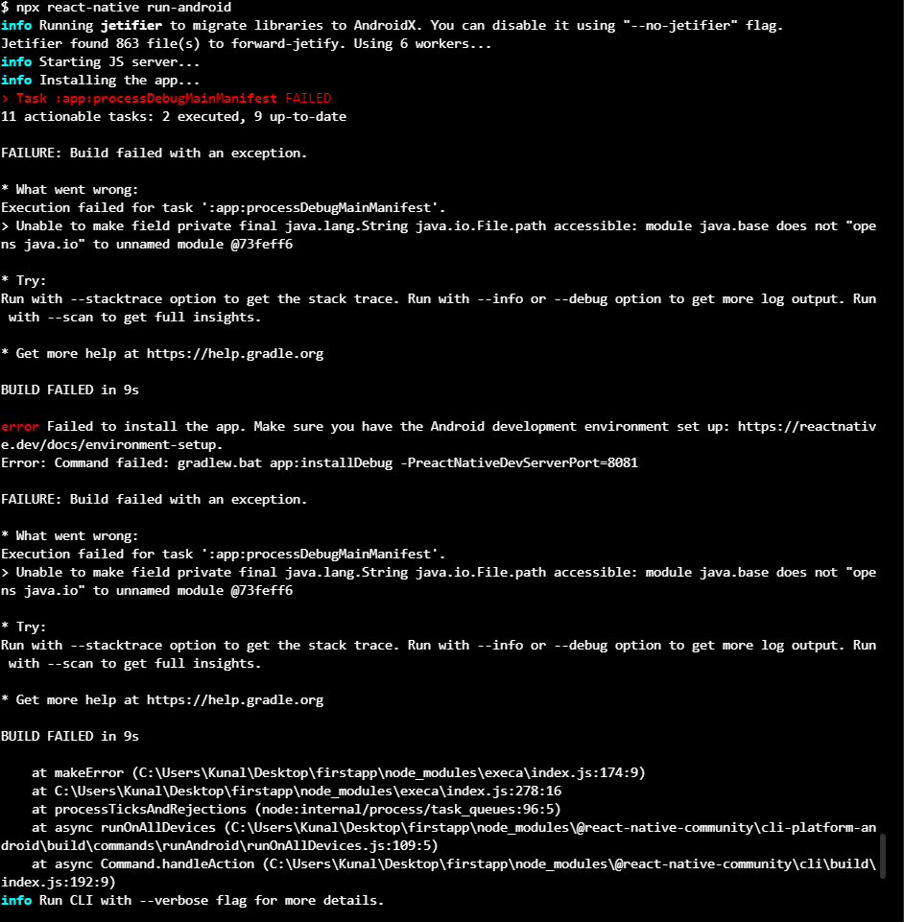If npx react-native run-android fail to build app

Solution

https://stackoverflow.com/questions/66696339/first-react-native-app-task-appprocessdebugmainmanifest-failed/66951023#66951023

What worked for me on JDK 17, and should for JDK 16 too:

Append the following line to the ./android/gradle.properties file in your project:

org.gradle.jvmargs=--add-opens java.base/java.io=ALL-UNNAMED

You may need to stop existing Gradle instances if some are already running, the easiest way would be to restart your OS.

That's it!

I haven't encountered any other issues using JDK 17 with React Native so far

**How to make a react native app project**

1. Cmd cd Desktop/
2. npx react-native init AwesomeProject
3. What worked for me on JDK 17, and should for JDK 16 too:
4. Append the following line to the ./android/gradle.properties file in your project:
5. org.gradle.jvmargs=--add-opens java.base/java.io=ALL-UNNAMED
6. connect devices usb or skipt to 7 for android studio simulator
7. npx react-native run-android

npm install --legacy-peer-deps

use the above to npm i in this

**to update the packages and dependecies to latest of an old project**

npm install -g npm-check-updates

ncu -u "to check all the upates avalible"

ncu -u "type again to update the package.json iwth correct version"

npm i "to install all the latest version"